Greco-Roman Philosophy

Ancient Greeks would not recognise our ‘democracy’ – they’d see an ‘oligarchy’
Published: June 3, 2016 12.19pm SAST

Author
- Paul Cartledge
A.G. Leventis Senior Research Fellow, Clare College, University of Cambridge

Disclosure statement
Paul Cartledge is vice-chair of the British Committee for the Reunification of the Parthenon Marbles.

Partners

University of Cambridge provides funding as a member of The Conversation UK.
The Conversation is funded by the National Research Foundation, eight universities, including the Cape Peninsula University of Technology, Rhodes University, Stellenbosch University and the Universities of Cape Town, Johannesburg, Kwa-Zulu Natal, Pretoria, and South Africa. It is hosted by the Universities of the Witwatersrand and Western Cape, the African Population and Health Research Centre and the Nigerian Academy of Science. The Bill & Melinda Gates Foundation is a Strategic Partner. more

We believe in the free flow of information
Republish our articles for free, online or in print, under Creative Commons licence.
Republish this article
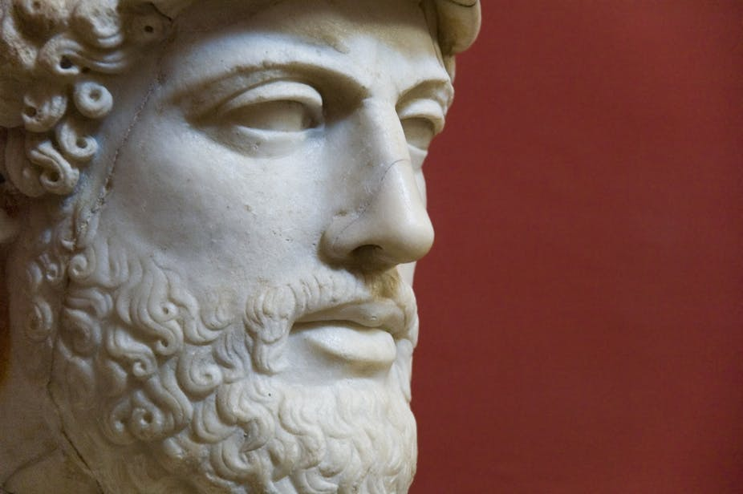
Pericles had some rather advanced ideas about politics. PabloEscudero, CC BY-SA
Share article
Print article
We owe to the ancient Greeks much, if not most of our own current political vocabulary. All the way from anarchy and democracy to politics itself. But their politics and ours are very different beasts. To an ancient Greek democrat (of any stripe), all our modern democratic systems would count as “oligarchy”. By that I mean the rule of and by – if not necessarily or expressly for – the few, as opposed to the power or control of the people, or the many (demo-kratia).
That is the case even if – and indeed because – the few happen to be elected to serve by (all) the people. For in ancient Greece elections were considered to be in themselves oligarchic. They systematically favoured the few and, more particularly, the few extremely rich citizens – or “oligarchs”, as we now familiarly call them thanks to Boris Berezhovsky and his kind, who are also known as “plutocrats” or just “fat cats”.
On the other hand, there are some significant commonalities between ancient and modern ways of thinking politically. To both ancient and modern democrats, for example, freedom and equality are of the essence – they are core political values. However, freedom to an ancient Greek democrat didn’t just mean the freedom to participate in the political process but also freedom from legal servitude, from being an actual slave chattel.
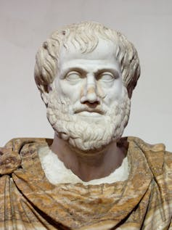
Aristotle favoured the democratic model. Jastrow, CC BY
And freedom to participate meant not just the sort of occasional saturnalia that we take to be the key mode of democracy for most of us – a temporary exchange of roles by political masters and slaves come general or local election (or referendum) time. But rather the freedom actually to share political power, to rule on an almost day-to-day basis.
In the fourth century BC(E), the Athenian democratic assembly of 6,000-plus adult male citizens met on average every nine days or so. It was government by mass meeting, but also the equivalent of holding a referendum on major issues every other week.

Equality then and now
Equality today is but a pipe dream at best, at least in socioeconomic terms, when the richest 1% of the world’s population owns as much as the remaining 99% put together. They managed these things a whole lot better in ancient Greece, and especially in the ancient Athenian democracy.
Statistical data are lacking – the ancients were notoriously unbureaucratic and they considered direct personal taxation to be a civic insult. But it’s plausibly been argued that “Classical” (5th-4th century BCE) Greece and especially Classical Athens were more populous and urbanised societies, with a higher proportion of their population living above the level of mere subsistence – and with a more equal distribution of property ownership – than has been the case in Greece at any time since, or indeed than in pretty much any other pre-modern society.
This does not mean that ancient Greece can supply us with a directly transferable example for democratic imitation – we tend to believe formally in the absolute equality of all citizens at any rate as adult voters, regardless of gender, and not to believe in the validity or utility of the legal enslavement of human beings as chattels.

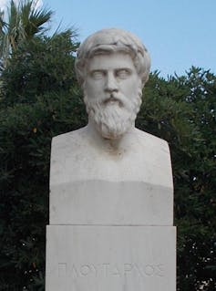
Plutarch: preferred the notion of monarchy. Odysses, CC BY
However, there are a number of ancient democratic notions and techniques that do seem highly attractive: the use of sortition, for instance – a random method of polling by lottery that aimed to produce a representative sample of elected officials. Or the practice of ostracism – which allowed the population to nominate a candidate who had to go into exile for 10 years, thus ending their political career.
And comparison, or rather contrast, of our democracies with those of ancient Greece does serve to highlight what’s been called creeping crypto-oligarchy in our own very different (representative, not direct) democratic systems.

Worst of all possible systems
We are all democrats now, aren’t we? Or are we? Not if we consider the following five flaws variously embedded in all contemporary systems.
Most pertinently at the moment, it was possible for the US and the UK to go to war in Iraq in 2003, even though neither US president George W Bush nor the UK prime minister, Tony Blair, had at any point received the endorsement for that decision from the majority of their own citizens.
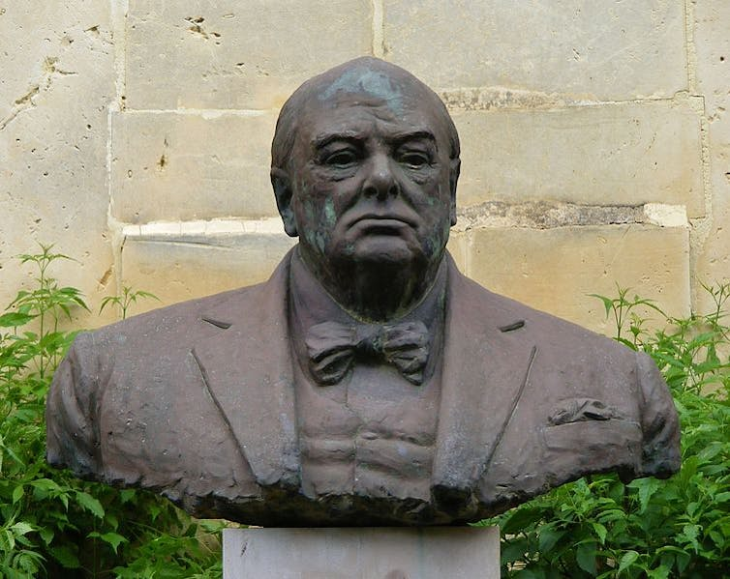
Churchill: the worst of all possible systems. Pygar1954, CC BY
Citizens in our “democracies” spend up to one-fifth of their lives governed by a party or candidate other than the party or candidate that most of them voted for at the last election. Moreover, elections are not in fact “free and fair”: they’re nearly invariably won by the side that spends the most money, and thus are more or less corrupted thereby.
When it comes to winning elections, no party has ever come to power without (blatantly self-interested) corporate backing in one shape or another. And, perhaps most damning of all, the vast majority of people are systematically excluded from public decision-making – thanks to vote-skewing, campaign financing and the right of elected representatives simply to ignore with impunity anything that happens in between (local or general) elections.
Democracy in short has changed its meaning from anything like the “people power” of ancient Greece and has seemingly lost its purpose as a reflection let alone realisation of the popular will.
One can well see why Winston Churchill was once moved to describe democracy as the worst of all systems of government – apart from all the rest. But that should be no good reason for us to continue ignoring the widely admitted democratic deficit. Back to the future – with the democrats of ancient Greece.

Greek Philosophy: A Unique Culture that Helped Build the Modern World

Table of Contents
- Pre-Socratic Philosophy
- The First Cause
- The Rise of the Sophists
- Socratic Philosophy
- Post-Socratic Philosophy
- The Golden Age of Greek Philosophy
- The Ongoing Role of Greek Philosophy
The Greeks and philosophy go together like peas and carrots. It’s nearly impossible to mention one without the other.
In many ways, philosophy was the Greeks’ greatest contributions to world history. Not only did they introduce new ideas but they also introduced totally new ways of thinking. This set in motion the wheels of change, helping humanity transition from a species reliant on mysticism and belief to one dependent on science and proof.
Many of the ideas introduced by the ancient Greek philosophers are still relevant today, and some of the questions they ask remain unanswered. But while we can debate their ideas, it’s hard to argue about the influence the Greeks had on both ancient and modern thought.


Pre-Socratic Philosophy
In general, ancient Greek philosophy can be broken up into three different parts: pre-Socratic, Socratic, and post-Socratic, aka Hellenistic.
The word Socratic comes from Socrates, arguably the most famous of all the Greek philosophers. He is used as the marker of different eras in Greek philosophy because the ideas being discussed before, during, and after his time were all very different.

The First Cause
For the pre-Socratics, the big question they were trying to answer was: where does life come from?
Phew, an easy one.
Part of the reason they may have been concerned with this is because ancient Greek religion did not have a single creation story. They believed the gods were involved, somehow, but there was little agreement as to how.
Therefore, there was a lot of room for interpretation, and people would have been willing to listen to new ideas.
One of the first people to delve into this topic was Thales of Miletus, a city on the Ionian coast, which is in modern-day Turkey. He believed that the origin of life was in water, making him one of the first people on record to say that life was not created by the gods. Talk about a game changer.
From there, philosophers came up with all sorts of different theories. For example, Pythagorus argued that numbers were the only truth in the universe. He said, just as numbers have no end and no beginning, so too does life. It’s merely a constant flow from one state to the next.
Woah…that’s deep.
Pythagorus is also famous for creating his theorem about triangles. Discovering a mathematical law so reliable would have provided some nice proof to his idea that numbers were all that mattered.
Later on came a man named Democritus, and he was most concerned with understanding the smallest particles in the Universe. He thought that if we could understand these, we could understand everything. Such a theory gave birth to the concept of the atom.
Another Pre-Socratic philosopher, Anaxagoras, argued that the universe once existed as a mixture of all matter in infinitely small parts and that, eventually, that mixture began to expand into the known Universe. While hardly as scientific, this is one of the first examples of what we now call the Big Bang Theory.
In the end, the pre-Socratic philosophers were unable to prove any of their theories. But they were touting around ideas that were entirely new. However, more importantly, they helped logic and reason gain importance in society.
Previously, people just accepted whatever someone told them was true, especially when it had to do with the gods. But thanks to the pre-Socratics, people started stopping and saying, “Wait a minute…why is that true?”
This tradition of questioning and seeking a logical explanation to things in the world planted the seeds for the scientific method, which is still the primary means of investigation in the modern world.

The Rise of the Sophists
Another major contribution the pre-Socratics made was that they made philosophy cool in ancient Greece. While their theories were controversial, people liked hearing them. And they also liked the ways in which these people presented their ideas.
Therefore, wealthier members of society began hiring philosophers to come and teach them, not only about their ideas but also about how to be persuasive and effective while talking.
Such a practice would have been highly valued in a place such as Athens since it operated as a democracy. Being able to speak eloquently and persuasively could earn you a lot of power.
These teachers were called Sophists, and they were basically the world’s first professional philosophers. That you could make a living learning and teaching philosophy just encouraged more people to follow this path, opening the door for even more philosophy down the road.


Socratic Philosophy
In around 470 BC, in a small Greek town named Alopece, a man named Socrates was born. Soon, he would move to Athens and start thinking and writing, changing the world along the way.
Unlike the philosophers that came before him, Socrates was less concerned with the origin of life and the Universe and instead focused more on issues of morality and ethics, as well as epistemology, which is the study of “how we know what we know.”
He believed that it was impossible to know anything for sure, and he taught people to relentlessly question everything they saw and experienced so that they could better understand it.
This approach gave way to the “Socratic Method,” which is a style of inquiry based on questioning that is still in use today — this is why modern court cases involve lawyers asking witnesses lots of questions.
Eventually, however, Socrates asked too many questions and started annoying the people in power. He was accused of heresy, found guilty, and sentenced to death.
His student, Plato, continued his legacy and also built on it. His primary focus was on government, as in, which is the best form?
A big reason for this shift that took place during this time is that this era was defined by war. First, the Greeks fought the Persians. Then, Athens and Sparta fought, then Sparta and Thebes, then Thebes and Athens, then everyone.
Seeing all this war, and all its consequences, likely provoked these philosophers to wonder “what form of government would best help us avoid all of this?”
The next most famous Socratic philosopher is Aristotle. He was Plato’s student, but he was interested in very different things. Mainly, Aristotle was concerned with understanding the physical world, but he applied elements of the Socratic method to his studies, helping bring this technique into the world of science.
Overall, these three philosophers and their contemporaries made many contributions to Greek society. But perhaps the most important was that they helped establish logic and reason as the primary means of understanding something. In doing this, they had a dramatic impact on how we see and understand the world today.

Post-Socratic Philosophy
The last branch of ancient Greek philosophy is called Post-Socratic, or Hellenistic. It emerged after Socrates (duh), during the time when Greek kingdoms stretched from Greece all the way to India.
During this period, the focus of philosophy switched from thinking about broad issues such as society, government, and ethics to issues of happiness and personal satisfaction.
A big reason for this may have been that the Greek world was at its most prosperous during this time. Yet despite all this wealth and abundance, the normal suffering of existence persisted. Therefore, the Greek philosophers of this time often asked, “What makes for a good life?”
An interesting question, indeed, one that we are still trying to answer today.
To try and solve this mystery, these philosophers used the same logic and reason that had been developing during earlier eras of Greek philosophy, and they arrived at some very interesting conclusions.
For example, one major school to emerge during this time was Cynicism. These philosophers believed that the best way to live was in harmony with nature and against convention. To put this into practice, they often chose to live in poverty, and they set up settlements in the middle of nowhere so that they could live as disconnected from society as possible.
Followers of Cyrenaicism believed that the best life was one that was full of physical pleasure. They argued that virtue had no real benefit, and that the best way to live was by maximizing the joy you could experience in your body.
In a similar but different vein, followers of Epicureanism argued that the objective of life was not necessarily to maximize pleasure but rather to minimize pain, both mental and physical. So, they pursued lifestyles that allowed them to live at peace.
Stoicism, on the other hand, centered around the idea that there were certain things humans could not change, and that happiness and peace could be found only by accepting this truth.
Other schools that emerged during this time include Skepticism, which doubted humans’ ability to ever know truth, as well as Megarian philosophy, which introduced the world to concepts such as conditional logic.

The Golden Age of Greek Philosophy
Many other versions of philosophy emerged during this time, and this was in part due to the widespread influence of Greek culture.
Because there were so many Hellenistic kingdoms spread out over such a large swath of territory, philosophers could come from anywhere, which meant they could have very different ideas and perspectives on life.
They would travel the Hellenistic kingdoms, learning new things and teaching one another, particularly in places such as Alexandria and Antioch, the two biggest cities of the Hellenistic world.
This may have been one of the high points in the history of philosophy. Being a philosopher at this time would have earned you considerable prestige, especially if you could recruit a following to your ideas.
Therefore, the field flourished and gave the world more ideas than it had ever had before. For example, never before had human happiness been such an important issue. And by bringing it to the forefront and subjecting it to scientific thought, it becomes a key concern of people.
From this point on, life was no longer about pleasing the gods and making it to the afterlife. There was now a strong desire to live well, and lots and lots of ideas about how to do it.


The Ongoing Role of Greek Philosophy
Although these philosophers all lived more than 2,000 years ago, their ideas remain as relevant as ever. The questions they asked remain some of the biggest mysteries we as a species face, and the methods they used to answer these questions make up the foundation of modern science.
In fact, the Greek philosophers were so important that they were the inspiration for Renaissance thinkers. This was the period of time in Europe from c. 1400-c. 1700 in which art and science flourished after centuries of oppression from the Catholic church. It had a profound impact on the development of the modern world, and it was all made possible thanks to the works of the Greek philosophers.
Today, Greek philosophy is required reading for anyone wishing to study the field. But even if you don’t become a student of philosophy, it’s impossible to avoid the influence of the Greeks. Their thoughts and ideas are everywhere!
Written by Matthew Jones

- Home
- Books
- Philosophy

- Mythology

- History

- Course
- About
- Podcast
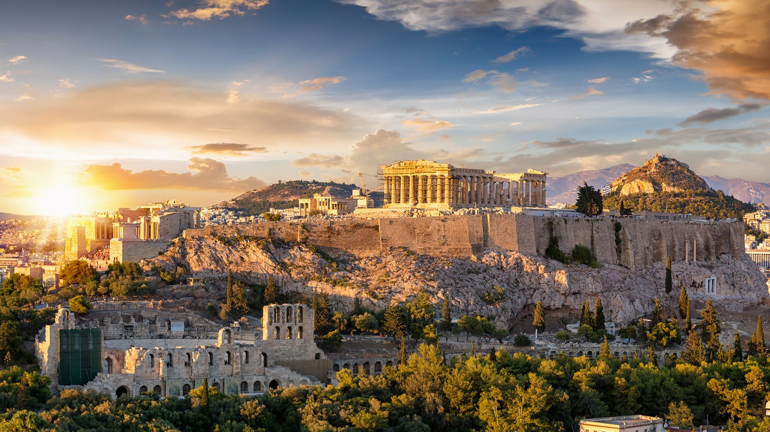

The Influence of Ancient Politics on Modern Political Systems
by KristinD on December 2, 2020
Written by Michael C. Anderson, Contributing Writer, Classical Wisdom
Most people believe ancient political systems have had a minimal effect on politics of the modern and postmodern world. The common belief is that the ancient world was largely barbarian with human rights virtually non-existent, so history from that time must be discounted.
Is this a correct assumption, or is there something can we learn about politics from antiquity?
The earliest Western civilizations were theocratic, but that model became obsolete with the advent of warfare. Winning in battle required military leadership and the power generated by a military leader’s success led to the evolution of kingship as the center of civil power in the state.
The next step in the evolution of government was the monarchy, which bolted hereditary authority onto the kingship model. Monarchies were the most common form of government before the Enlightenment. They survived because the authoritarian state could manage the society efficiently and, at the same time, protect its status.
In the midst of the monarchies permeating the ancient world, stood two models that would foreshadow modern politics: the Greek Democracy and the Roman Republic. These governments were true innovations in the application of liberty and human rights.
The mountains of Greece were an opportune setting for democracy. They divided the Greek landscape into small spaces which acted as incubators for the development of rights-based political systems. After the Mycenean civilization ended, the Greek peninsula descended into a dark age period, where political and social advancement came to a halt. Then slowly, small communities, governed by the people, began to develop. These communities blocked attempts by the wealthy to gain power, keeping control in public hands.
The Polis evolved to became the standard form of government across Greece after 700 BC. Each Polis developed its own characteristics, but all featured the institutions of democracy. In time, Athens became the most famous of the Poleis, because of its size and influence over the Greek peninsula. Athens developed its final democratic form after periods of tyrants and a flirtation with republicanism under Solon. Its high point occurred during the so called “Golden Age,” in the fifth century BC, when Pericles was its leader.
The Golden Age was also the beginning of the end for Athens, because she would soon be defeated by Sparta in the Peloponnesian War. The structure of the Polis had weakened and the advent of the sophists ushered in a new focus on the individual, replacing the cultural unity that had existed previously. It was only 60 years after the Peloponnesian war that Philip of Macedonia (father of Alexander) subdued the Greek peninsula and the Polis passed out of existence.
The story of Rome was vastly different. Rome began as a hilltop community founded near a ford in the Tiber River, in a part of Italy known as Latium. The early tribes of Rome were farmers, married to the land.
Rome was far from the sea, and its people had no history of sea trade, so land was its most valuable asset. Early Rome was influenced by the nearby Etruscan civilization. Its customs and government structure were readily adopted by the Romans. Two of the early kings of Rome were Etruscans.
Rome could not tolerate a monarchy. It threw off the last of the kings in 509 BC and became a republic. The word republic comes from the Latin res publica, or “thing of the people.” This thing of the Roman people was the rights they obtained through the people’s assembly. The republic featured an executive branch consisting of elected magistrates, led by a pair of consuls. The legislative branch consisted of the Senate and the people’s assembly. The assembly could pass laws but not propose them. The Senate could propose laws but not vote on them.
In the early days of the republic, Rome was dominated by the wealthy patrician class. Descendants of the three original Roman tribes, the patricians, controlled money and power in the republic. The Plebians had no rights in the beginning, but through organized efforts, they won for themselves an expansion of their rights.
They fought for executive branch representation, so the college of tribunes was created. They demanded written laws, so the twelve tables were posted in the Forum. They demanded access to all elected offices and this was also granted by the Senate over time. What made the Roman republic work was the willingness of the Senate to extend rights to all citizens. That reality prevented instability and allowed Rome to prosper.
But the republic did not survive. After 400 years, it began to crumble because of mistakes by the Senate, inefficient government, and territorial expansion, which required a large army. Until the end of the second century BC, Rome had a citizen army; farmers put down their implements and went to war.
In 107 BC, Gaius Marius, the leading general in the republic, created a professional army. This caused the soldiers to shift their loyalty from the Senate to their commander. Now any general, with a lust for power, could bend the army to his will and overthrow the government. That fear became a reality when Julius Caesar made himself permanent dictator, leading to the collapse of the republic.
The founding fathers of the United States knew the stories of Athens and Rome. Most could speak Latin and Greek, and they had read the history of antiquity in the original language. When it came time to create the American Constitution, they thought long and hard about the design of their new government. The United States would be the first “new” nation in the last thousand years of Western civilization, but what form should its government take?
The founders looked to the models of Greece and Rome as templates. In a short time, the Greek model was rejected. The polis was small enough so that citizens could attend meetings of the assembly and vote. This was not possible in a territory as large as the thirteen colonies. The new government had to be built on representation; elected officials representing citizens.
The founders had the experience of the colonial governments to draw upon and they understood the British Constitution. They decided that adapting the Roman republic to America would be the most logical approach.
During the Constitutional Convention, the design of each branch of government was debated at length. There was early agreement on the Legislature which would contain an upper class of “elders” and a people’s assembly. There was a long negotiation about how the legislature should be constituted and how the representatives should be elected. A balance was reached by having two senators per state and an assembly determined by population distribution. Senators would be elected by the states and representatives directly by the people.
The executive branch was also subject of a lengthy debate. How would the chief magistrate (president) be elected and for how long? In the end, the delegates chose a presidential term of four years with the president elected by the states.
The founders looked at the new government as a republic of state republics. The states would share power with the Federal government with no overlap of jurisdictions. The founders believed that too much democracy was dangerous: that the public could be influenced to vote for a tyrant. Better to have the senior legislative chamber and the president elected by the states.
They also battled over the power of the Federal government. Some wanted it to be small, only functioning in areas inappropriate for states, like treaties with foreign governments. Others wanted it to have more power, thinking that professional politicians from the elite class would be the best managers of the country.
America’s founders learned much from the ancient governments of Greece and Rome. They could read about the impact of citizens as direct participants in government. They had the luxury of analyzing systems that failed so they could avoid those same problems.
The debate about the structure of the American government has continued from the time of the Constitution until the present day. During the passage of time, the Federal government has grown exponentially, as the demand for its programs have increased, the courts have accommodated the shifting of the role of the Federal government to one as caretaker for society, and the American social culture has changed enormously. There is no playbook for how to adapt a political system to these types of changes, but we have history to guide for the direction we have to take now.
The Enlightenment helped us see that individual rights were important. That concept allowed democracies to take over the world as the default political system. The ancients taught us about the value of tradition as applied to changing societies. Tradition has to be used as a guide for moving forward, because too much change creates instability. The French Revolution warned us what can happen when all traditions are discarded.
Why is the study of ancient political systems important? The answer lies in the fact that all human societies are experiments in a public morality built by a consensus of the individual moralities of their citizens.
Man did not evolve to live among strangers; he evolved to live among small kinship groups. There are no human socio-psychological mechanisms to cope with living in societies, so each iteration becomes a unique model. The brilliance of the ancients is that their ideas can accommodate the postmodern society. The ancients understood human nature well enough to create models that are timeless and function at any time and place.

Four Ancient Greek Ideals that Influenced American Independence
Bytanaskidis
July 4, 2021
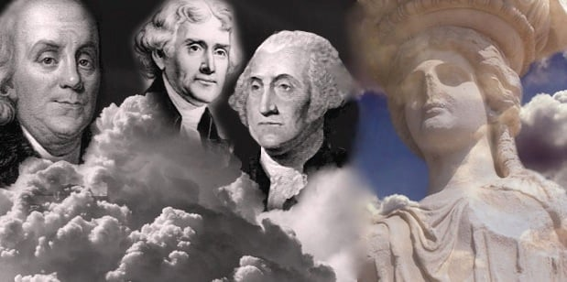Credit: A. Makris / Greek Reporter
On Fourth of July, beyond the American Independence, we also celebrate the universal ideals of Ancient Greece that serve as the foundations to the western world. The ideas and practices that led to the development of the American democratic republic after 1776 owe a debt to the ancient civilization of Greece. The Greek ideals of democracy and the Rule of Law, now provides people around the world with a means of protecting their human rights and holding each other accountable as equals under the law.
All of America’s founding fathers, who were faced with the momentous task of creating a government of their choosing, had studied ancient Greek philosophers’ texts, drawing inspiration about morals, ethics and the sense of independence, all fundamental principles of a democratic society.
They looked to what they deemed the best philosophies and examples of government throughout world history. Along with the Roman model, the democratic model of ancient Greece’s system of self-government greatly influenced how the founding fathers set out to construct the new United States government.
US State and Greek polis
A U.S. state resembles the community structure of an ancient Greek polis or city-state. A polis was composed of an urban center and the land surrounding it, developments similar to that of the major cities and state capitals in the United States and the rural areas surrounding them.
In ancient Greece, some of the main city-states were Athens, Sparta, Corinth, Thebes, and Syracuse. These city-states acted independently for the most part. However, sometimes they engaged in a war against each other. They also banded together to defend Greece from foreign invaders.
Historian and professor Carl J. Richard notes that from Herodotus and Plutarch, the founders learned the story of the Persian War, the near miraculous victory of the tiny Greek republics over the seemingly invincible Persian empire.
“From this tale, the founders learned that it was possible for a collection of small republics to defeat a centralized monarchical empire in a war for survival. This was a crucial lesson because the founders faced just such a power in the Revolutionary War,” he adds.
Rule of Law
All Greek city-states had sets of rules by which the people lived in observance and laws they were required to obey. In ancient Greece, the idea of Rule of Law came from philosopher Aristotle and his belief in natural law. He claimed the existence of a higher justice in nature—certain essential rights—that superseded the laws written by humans. Aristotle believed that people should align themselves with this natural law and govern by its ethics.
In the United States today, the Rule of Law is a principle that ensures that all laws are publicly accessible, equally enforced, and independently judged and that they adhere to international human rights ethics. The Rule of Law is important because it allows all individuals and institutions (including the government itself) to be held accountable for their actions. By agreeing to follow the Rule of Law, the United States can prevent abuses of power by leaders who might act as if they are above the law.
F. A. Hayek, in The Constitution of Liberty, traces the very concept of the rule of law to the Greeks. But such should be expected. If the Greeks advocated natural law they would also advocate the rule of such law. This is what Aristotle meant when he said “it is more proper that the law should govern than any of the citizens.”
Written Constitution
Another important ancient Greek concept that influenced the formation of the United States government was the written constitution. Aristotle, or possibly one of his students, compiled and recorded The Constitution of the Athenians and the laws of many other Greek city-states. Having a written constitution creates a common standard as to how people should behave and what rules they must follow. It also establishes clear processes by which people who break the law are judged and those who are harmed as a result can be compensated or given justice.
Like The Constitution of the Athenians, the U.S. Constitution is a vital document. It lays out the government’s structure and how the checks and balances of power within it, relate to one another. The U.S. Constitution acts as the supreme law of the country and establishes individual citizens’ rights, such as the right to free speech or the right to a trial by a jury of one’s peers. Today, the U.S. Constitution is still regularly referenced in law as the supreme law of the land and is enforced by the U.S. Supreme Court, the country’s highest court.
Voting system
The original U.S. voting system had some similarities with that of Athens, where every citizen could speak his mind and vote at a large assembly that met to create laws. Citizens were elected to special councils to serve as organizers, decision-makers, and judges. However, the only people considered citizens in Athens were males over the age of 18. Women, slaves, and conquered peoples could not vote in the assembly or be chosen to serve on councils.
The founders of the United States similarly believed that only certain people should be allowed to vote and elect officials. They chose to structure the United States as a representative democracy. This means that citizens elect officials, such as senators and representatives, who vote on behalf of the citizens they represent in Congress. It also means that instead of each individual citizen voting for president directly, a body called the Electoral College officially casts the votes of each state for the president. As in Athens, when the United States was founded, only white, landowning men were allowed to vote. Over time, however, all U.S. citizens over the age of 18 who have not been convicted of a felony have gained the right to vote.

American Independence: US Presidents praise Ancient Greek ideals
Successive US Presidents have payed moving tributes to the contribution ancient Greece made to the ideas that shaped American Independence and western democracy.
Standing next to a Greek flag, US President Joe Biden sent a video message for Greek Independence Day on March 25, 2021.
“For 200 years our nations’ fates have been intertwined. Young people from the newly formed United States joined Greeks in their fight to defend democracy and individual freedom,” Biden said.
For his last foreign trip in November 2016, Barack Obama chose Athens. Standing on the Acropolis he said that with his visit he wanted to express his gratitude for all that Greece — “this small, great world” — has given to humanity through the ages.
“Our hearts have been moved by the tragedies of Aeschylus and Euripides. Our minds have been opened by the histories of Herodotus and Thucydides. Our understanding of the world and our place in it has been expanded by Socrates and Aristotle”, Obama said.
When he visited the Parthenon, “this symbol of western democracy,” he stressed that “our ideals about democracy our notions of citizenship, our notions of rule of law, began to develop here.”

Speaking in March 2019 in the White House, President Donald Trump said that “the U.S and the whole western civilization has been shaped by the achievements of the Greek people.”

